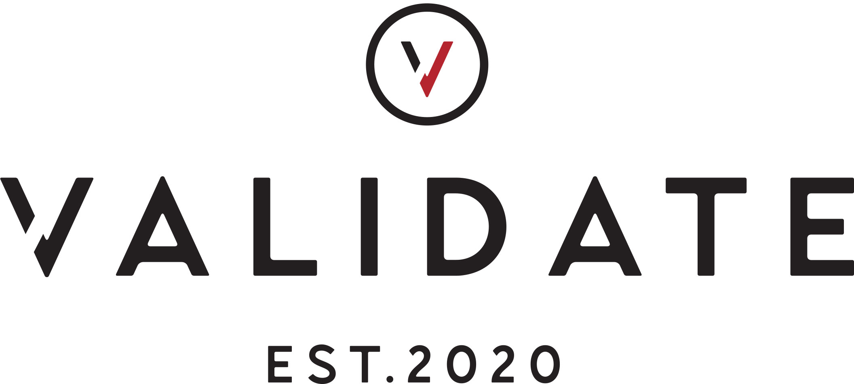**Please return your goods to:**

**Validate Returns  
Unit 16, The Howard Centre, Howardsgate, Welwyn Garden City,**AL8 6HA.

**RETURNS FORM**

Please fill out this returns form and include it in the parcel with the item(s) you would like to return.

|  |  |
| --- | --- |
| ORDER NO. | EMAIL |
| NAME | TELEPHONE |
|  |  |

Please fill out the below and supply a reason code.

|  |  |  |  |  |
| --- | --- | --- | --- | --- |
| PRODUCT NAME | SKU CODE | QTY | RETURN | REASON CODE |
|  |  |  |  |  |
|  |  |  |  |  |
|  |  |  |  |  |
|  |  |  |  |  |
|  |  |  |  |  |
|  |  |  |  |  |
|  |  |  |  |  |

|  |  |
| --- | --- |
| **RETURNS INFO** | **REASON CODES** |
| * We offer a ‘60 Days from date of receipt’ returns policy. * All items must be returned in the exact condition received, unworn, labels still attached and packaged. * Pack the items to be sent back securely in suitable protective packaging, together with the completed returns form * Post your item to the address on the top of this returns form and keep the tracking receipt as proof of return * Please retain proof of postage until it has been confirmed that your refund has been processed. * Once we have received your package, please allow up to 5 working days for your refund to be processed and issued. * Items returned outside of the 60 Day period will not be accepted. The item(s) will then be returned to you and an invoice issued. | 1. Too Large 2. Too Small 3. Looks different to online image 4. Poor quality/faulty 5. Incorrect Item received 6. Incorrect Item ordered 7. Other – Please specify below |