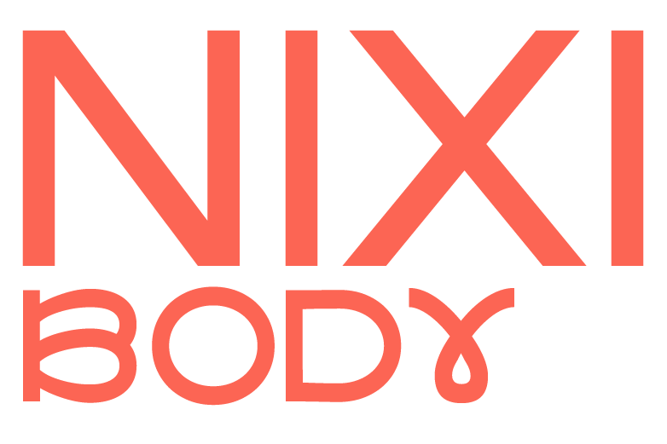

Return & Refund Policy
Thank you for shopping at Nixi Body
To be eligible for a return & refund for all items, your items must be unused and in the same condition that you received them. They must also be in the original packaging.
Please ensure that BP3 Incontinence & Period underwear is tried on over your own underwear. Our products are intimate products and for hygiene purposes we are unable to accept returns of any products that have been worn.
We do not accept returns after 60 days of ordering goods.
These are not suitable for full incontinence. Please see guidelines under knickers as to how much fluid the knickers are capable of holding.
To return your order, fill out the return slip, stick the pre-paid return label to your package and take your package to your nearest Collect+ drop off point. To find your local drop off point visit https://www.collectplus.co.uk/parcel-returns
Please retain proof of postage until it has been confirmed that your refund has been processed.
For more information or help, please contact Mountain Warehouse’s Customer Care

