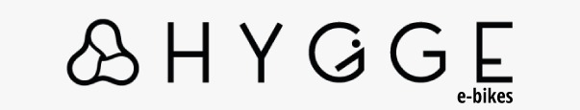

Thank you for your order!
This order was dispatched by Hygge Bikes Ltd.
We hope that you are happy with your purchase, but if you wish to return your order, please contact Mountain Warehouse Customer Care to arrange collection.

Below applies to E-Bikes only.
- The order must be returned within 60 days from receipt. Please note that the items must be unused and still have their original tags and packaging. There we will be a 50 GBP collection fee and a 100 GBP restocking fee should the customer decide to return product due to change of mind once it is confirmed the product is unused.

- If the product is used and customer and decides to return it, the return request will be rejected.

- If the product has defects then the customer will have the return arranged free of charge.

For Accessories
The order must be returned within 60 days from receipt. Please note that the items must be unused and still have their original tags and packaging. There will be no return fee charges.

Once the return request is accepted, Hygge Bikes Ltd will arrange the collection with the customer on a suitable date and time. Refund will be processed back depending on condition of the bike once it is evaluated upon return. Customer will receive full refund if bike is returned defective or partial refund deducting 150 GBP (collection and restocking fees) for change of mind returns once confirmed bike in non used and contains all packaging and items.

Instructions:
1. Complete the table below and pop it in the return parcel
2. Contact Mountain Warehouse Customer Care using the below contact information

Mountain Warehouse Customer Care contact information:
- Online: https://support.mountainwarehouse.com/hc/en-gb/requests/new
- Phone: 0203 828 7700

If you have any questions, please contact Mountain Warehouse Customer Care.
Please note that items sold by Hygge Bikes Ltd cannot be returned to Mountain Warehouse stores.

Customer Name: Order Number:

Item Being Returned | Reason for Return

