

Thank you for your order!

This order was dispatched by Dalesman.

We hope that you are happy with your purchase, but if you wish to return your order, please visit the below link or scan the QR code to register and receive your free Royal Mail returns label. The order must be returned within 60 days from receipt. Please note that the items must be unused and still have their original tags and packaging.

Instructions:

1. Complete the table below and pop it in the return parcel
2. Visit: http://www.royalmail.com/track-my-return/create/6108
or scan the QR code to create your FREE returns label

If you have any questions, please contact Mountain Warehouse Customer Care.

Scan Me

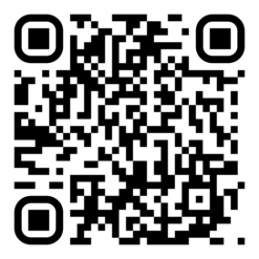

Customer Name:
Order Number:

Item Being Returned | Reason for Return

